LAB NO: 8
Experiment: Static Routing using Cisco Packet Tracer
Apparatus Required (in Cisco Packet Tracer)
- 3 ×Cisco 2811 Routers(Router0 and Router1)
- 2 × Cisco 2960 Switches (Switch0 and Switch1)
- 4 × PCs (PC0 – PC3)
- Copper Straight-Through Cables (to connect PCs to switches)
- 1 × Copper Straight-Through Cable (to connect Switch0 ↔ Switch1 uplink ports, e.g., Gi0/1 ↔ Gi0/1)
Tools Used
- Cisco Packet Tracer Software (simulation environment)
Theory
1. Introduction
Routing is the process of forwarding data packets from one network to another. Routers use a routing table to determine the best path to reach the destination. In Cisco networking, there are two main types of routing: Static Routing and Dynamic Routing.
Static Routing is a manual method where the network administrator defines routes by explicitly specifying the next-hop IP address or the exit interface on the router.

2. Static Routing Definition
Static Routing is a routing technique in which routes are manually configured on routers by the network administrator. Unlike dynamic routing protocols (such as RIP, OSPF, or EIGRP), static routing does not update automatically if there is a change in the network topology.

3. Characteristics of Static Routing
- Routes are manually entered into the router's configuration.
- No overhead of routing protocols (no bandwidth or CPU usage for route calculation).
- Best suited for small networks or networks with stable topology.
- Provides high security because routes are not advertised to other routers.
- Requires manual reconfiguration if network topology changes.

4. Advantages of Static Routing
- Simple to configure in small networks.
- More secure than dynamic routing since routes are not shared.
- No extra CPU or memory overhead.
- Predictable path for packet forwarding.
5. Disadvantages of Static Routing
- Not scalable for large networks (difficult to manage many routes).
- Lacks fault tolerance – if a link fails, traffic cannot be rerouted automatically.
- Manual updates required for every change in the network.

Static Route Command
The general syntax is:
ip route <destination_network> <subnet_mask> <next_hop_ip_address>
- destination_network: The network you want to reach (e.g., 192.168.2.0).
- subnet_mask: The subnet mask of the destination network (e.g., 255.255.255.0).
- next_hop_ip_address: The IP address of the neighboring router through which the packet should be forwarded (e.g., 10.1.1.2).

Lab Diagram:
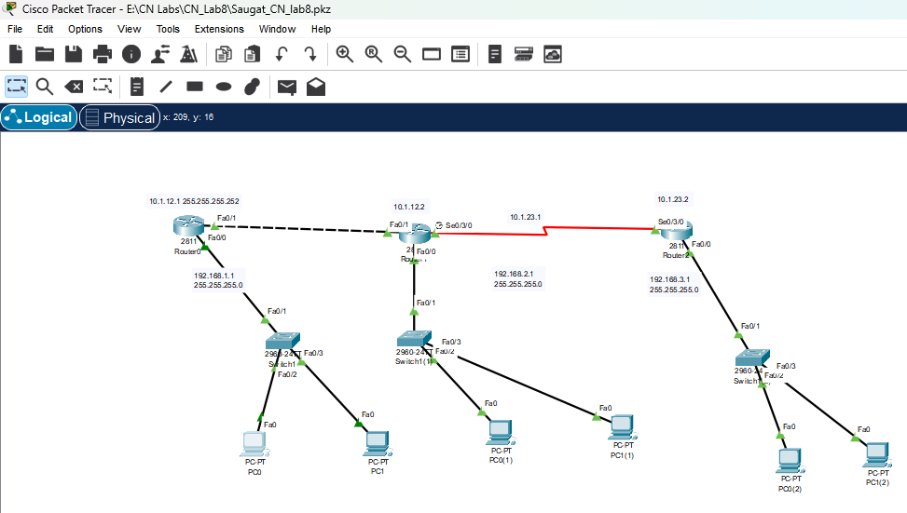

Procedure:
1. Network Topology Setup
- Open Cisco Packet Tracer.
- From the device list, drag and drop:
  - 3 × Routers (2911)
  - 3 × Switches (2960)
  - 6 × PCs (PC0 – PC5)
- Arrange them into three blocks:
  - Block-A: PC0, PC1 → Switch0
  - Block-B: PC2, PC3 → Switch1
  - Block-C: PC4, PC5 → Switch2
- Use Copper Straight-Through cables to connect PCs to their switches and switches to their routers.
- Also,connect all routers with each other.

2.Router Configuration
In router 1:
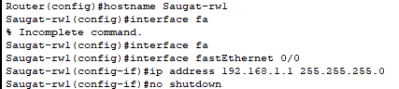
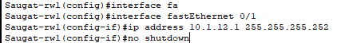

Check if ip interface are assigned correctly:
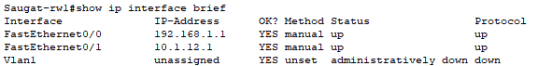

In router 2:
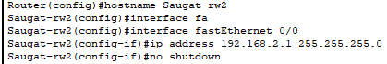
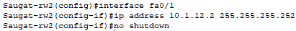
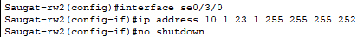

Check if ip interface are assigned correctly:
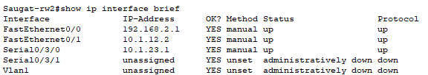

In router 3:
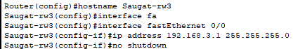
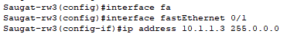

Check if ip interface are assigned correctly:
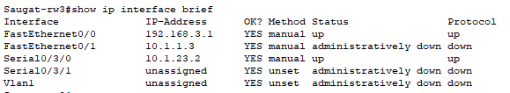

3.Set route in routers:
In router 1:

Check ip route:
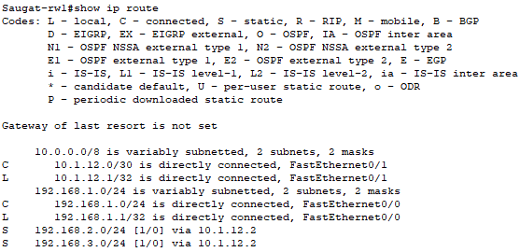

In router 2:

Check ip route:
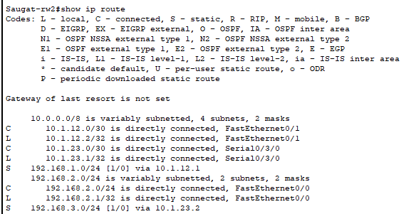

In router 3:

Check ip route:
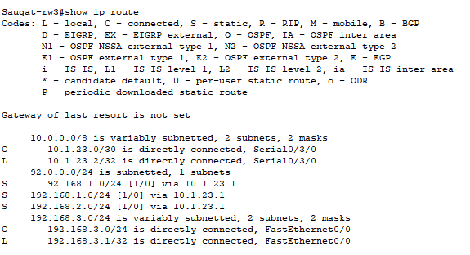

4.Configure DHCP in each router:
In router 1:
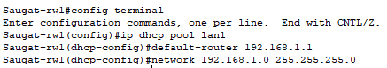

In router 2:
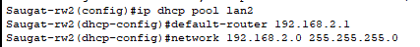

In router 3:
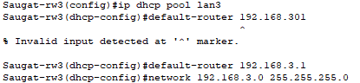

5.Now dhcp configuration in each pc:
In network 1 (192.168.1.0):
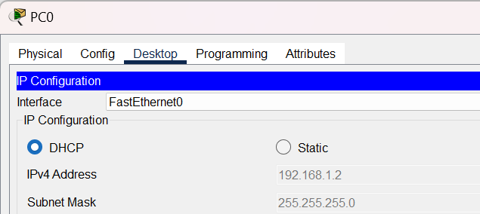
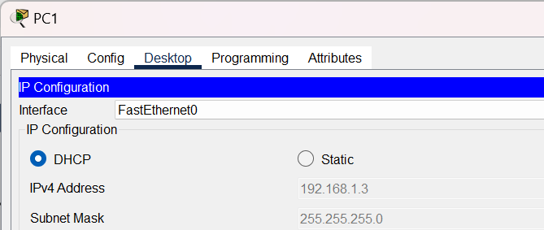

In network2(192.168.2.0):
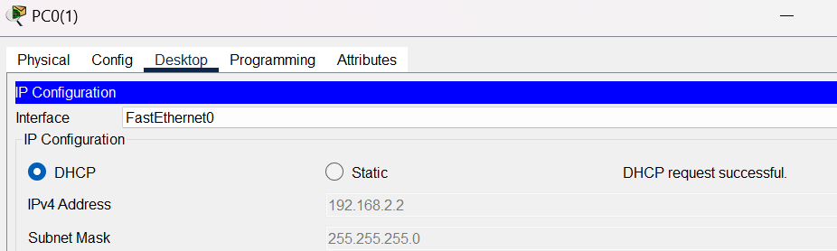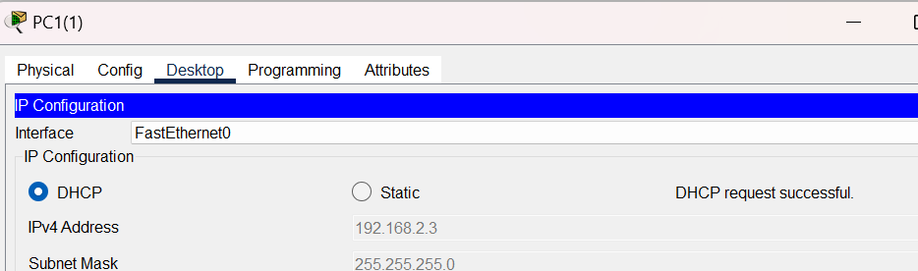

In network3(192.168.3.0):
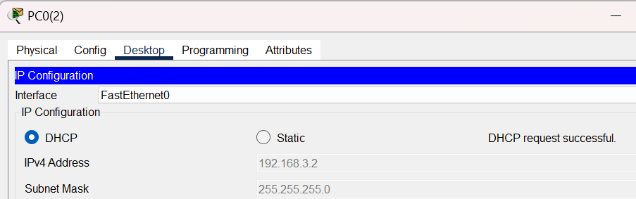
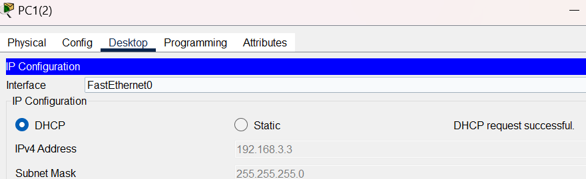

Testing:
1.ping from pc of netwrok1 to network 2,3:
i.e. 192.168.1.2->192.168.2.2, 192.168.1.2->192.168.3.2

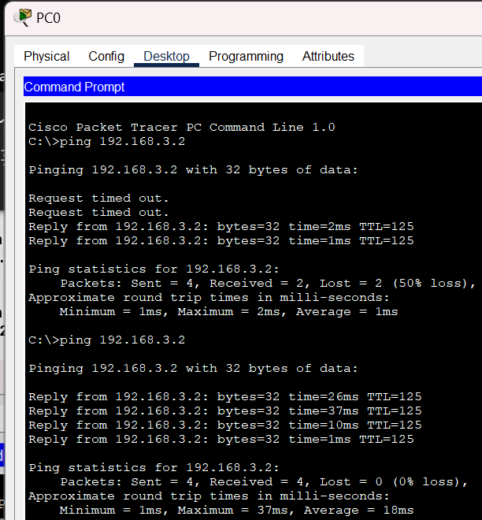

2.ping from pc of network 2 to networ1,network3:
i.e 192.168.2.2->192.168.1.2,192.168.2.2->192.168.3.2

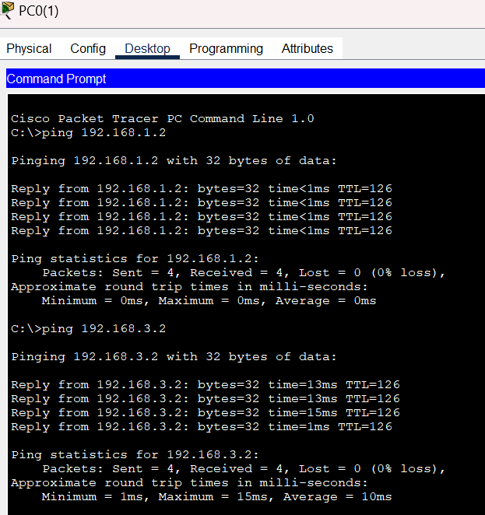

3. ping from pc of netwrok 3 to network 1,2 :
i.e 192.168.3.2->192.168.1.2, 192.168.3.2->192.168.2.2
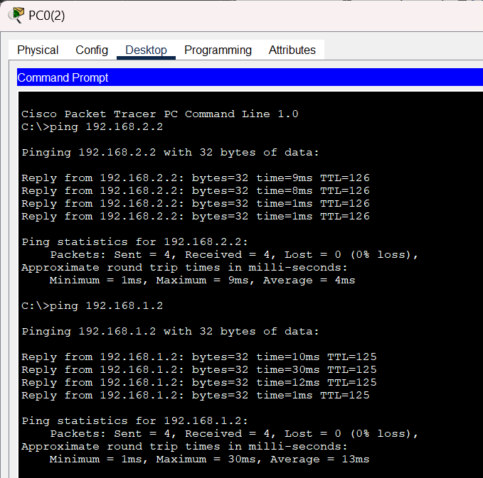

Conclusion
In this lab, we successfully implemented a multi-router network connecting three separate LANs (R1 LAN, R2 LAN, R3 LAN) using point-to-point links between the routers. The main objectives were to configure IP addresses, static routing, and inter-network connectivity, and then to verify that PCs across all networks could communicate.So, In this lab, we configured a multi-router network connecting three LANs using static routing. Each router’s interfaces were assigned proper IP addresses for LANs and inter-router links, and static routes were added to ensure all networks could communicate. PCs in each LAN were successfully able to ping PCs and gateways in other networks, confirming end-to-end connectivity. This lab demonstrated the importance of accurate IP addressing, interface configuration, and static route setup to achieve reliable inter-network communication.

